EXPERIMENT – 2
SIGNAL OPERATIONS AND TRANSFORMATIONS
OBJECTIVES

OBJECTIVE 1: AMPLITUDE SCALING AND TIME SCALING OF CONTINUOUS-TIME SIGNALS
clc; clear; close all;
t = -1:0.001:1;
x = sin(2*pi*5*t);
xA = 2*x;
xC = sin(2*pi*5*(2*t));
xE = sin(2*pi*5*(t/2));
figure;
subplot(4,1,1);
plot(t,x); grid on;
title('Original Signal x(t)');
subplot(4,1,2);
plot(t,xA); grid on;
title('Amplitude Scaled Signal 2x(t)');
subplot(4,1,3);
plot(t,xC); grid on;
title('Time Compressed Signal x(2t)');
subplot(4,1,4);
plot(t,xE); grid on;
title('Time Expanded Signal x(t/2)');
xlabel('Time (s)');
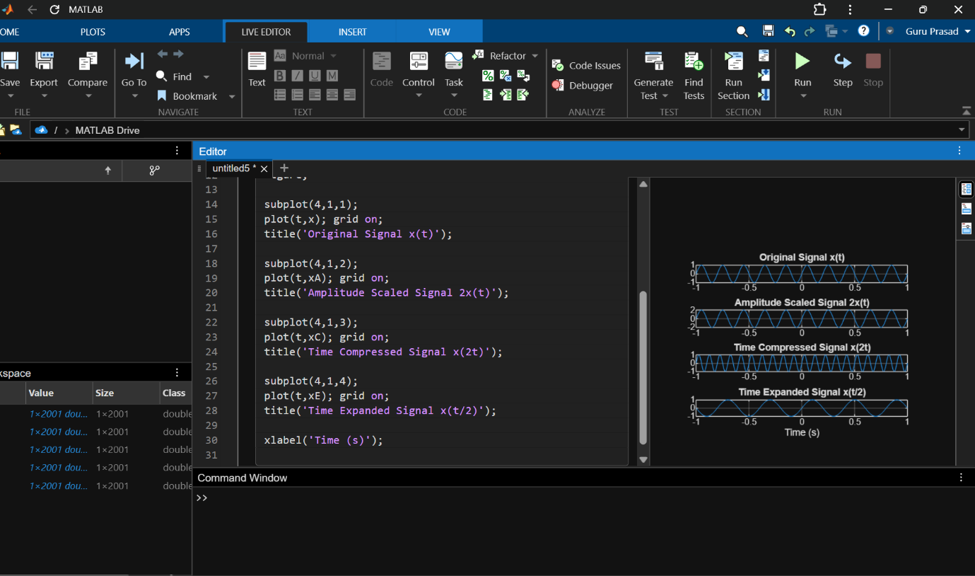

OBJECTIVE 2: TIME SHIFTING AND TIME REVERSAL OF CONTINUOUS-TIME SIGNALS
CODE :
clc; clear; close all;
t = -1:0.001:1;
x = sin(2*pi*5*t);
xS = sin(2*pi*5*(t-0.2));
xR = sin(2*pi*5*(-t));
figure;
subplot(3,1,1);
plot(t,x); grid on;
title('Original Signal x(t)');
subplot(3,1,2);
plot(t,xS); grid on;
title('Time Shifted Signal x(t-0.2)');

subplot(3,1,3);
plot(t,xR); grid on;
title('Time Reversed Signal x(-t)');
xlabel('Time (s)' 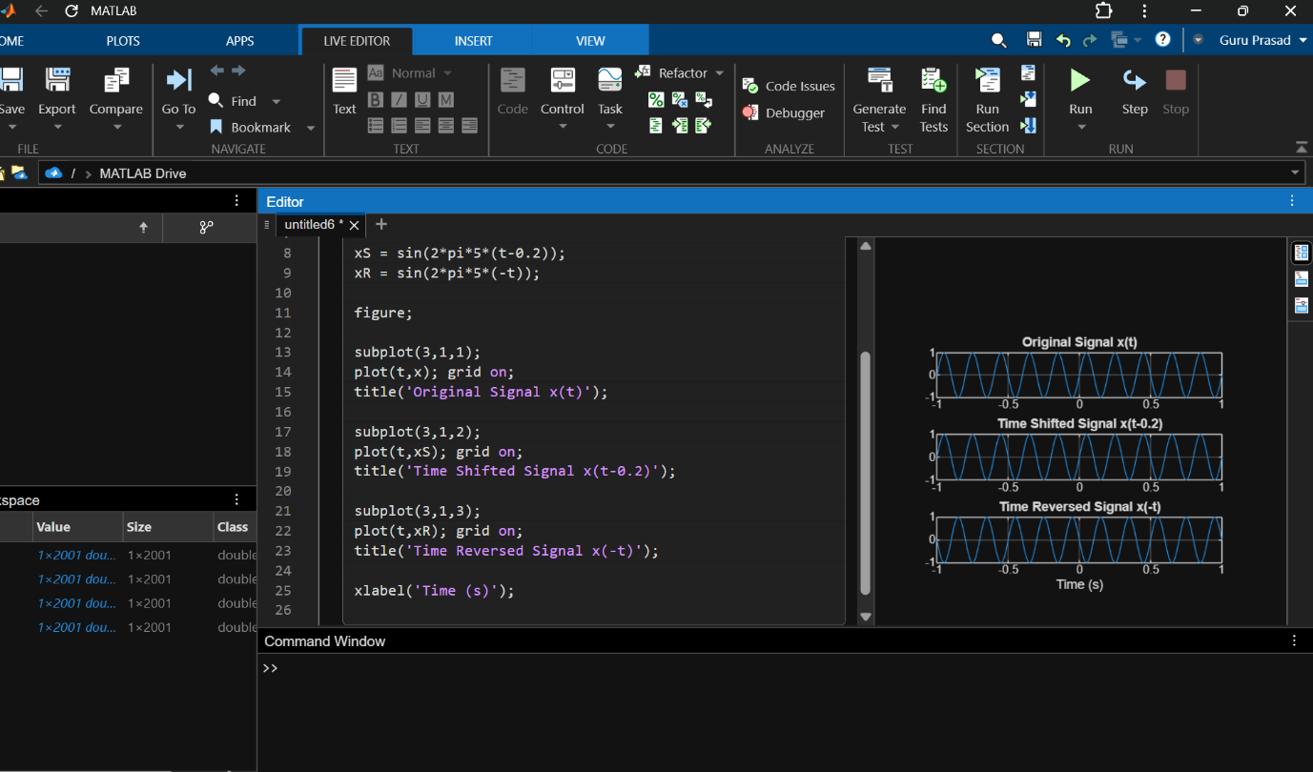

OBJECTIVE 3: ADDITION AND MULTIPLICATION OF DISCRETE-TIME SEQUENCES
CODE 3 :
clc; clear; close all;
n = 0:2;
x1 = [1 2 1];
x2 = [1 1 2];
xAdd = x1 + x2;
xMul = x1 .* x2;
figure;
subplot(2,2,1);
stem(n,x1,'filled'); grid on;
title('Sequence x[n]');
subplot(2,2,2);
stem(n,x2,'filled'); grid on;
title('Sequence y[n]');
subplot(2,2,3);
stem(n,xAdd,'filled'); grid on;
title('Addition x[n]+y[n]');
subplot(2,2,4);
stem(n,xMul,'filled'); grid on;
title('Multiplication x[n]*y[n]');
disp('Addition Result:');
disp(xAdd);
disp('Multiplication Result:');
disp(xMul);
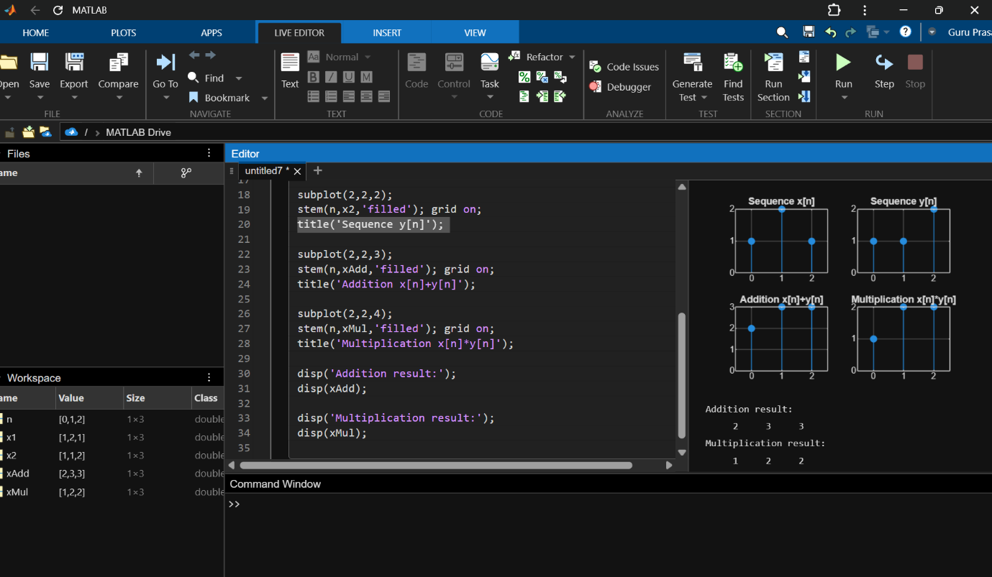

OBLECTIVE 4: VISUALIZATION AND COMPARISON OF SIGNAL OPERATIONS
CODE 4 :
clc; clear; close all;
t = -1:0.001:1;
x = sin(2*pi*5*t);
xA = 2*x;
xC = sin(2*pi*5*(2*t));
xE = sin(2*pi*5*(t/2));
xS = sin(2*pi*5*(t-0.2));
xR = sin(2*pi*5*(-t));
n = 0:2;
x1 = [1 2 1];
x2 = [1 1 2];
xAdd = x1 + x2;
xMul = x1 .* x2;
figure;
subplot(3,2,1);
plot(t,x); grid on;
title('Original x(t)');
subplot(3,2,2);
plot(t,xA); grid on;
title('Amplitude Scaled');
subplot(3,2,3);
plot(t,xC); grid on;
title('Time Compressed');
subplot(3,2,4);
plot(t,xE); grid on;
title('Time Expanded');
subplot(3,2,5);
plot(t,xS); grid on;
title('Time Shifted');
subplot(3,2,6);
plot(t,xR); grid on;
title('Time Reversed');
figure;
subplot(2,2,1);
stem(n,x1,'filled'); grid on;
title('x[n]');
subplot(2,2,2);
stem(n,x2,'filled'); grid on;
title('y[n]');
subplot(2,2,3);
stem(n,xAdd,'filled'); grid on;
title('Addition');
subplot(2,2,4);
stem(n,xMul,'filled'); grid on;
title('Multiplication');
